**PROJECT 3: WEATHER AND FOREST FIRES**

**Broad Categories:**

* **Comprehensive Fire Danger Rating Systems:**
  + **CFFDRS (Canadian Forest Fire Danger Rating System):** A complete system used in Canada, considering weather (temperature, humidity, wind) and fuel moisture to produce several indices, including the **Fire Weather Index (FWI)**. FWI is a core component of CFFDRS, focusing on fire behavior potential. The Canadian Forest Fire Weather Index (FWI) value doesn't have a fixed upper limit, meaning it can theoretically go to infinity as fire danger increases. However, values above 50 are considered extreme, and fires under such conditions can exhibit very intense behavior and be very difficult to control.

Here's a general breakdown:

* **0-10:** Low fire danger.
* **10-20:** Moderate fire danger.
* **20-30:** High fire danger.
* **30-50:** Very high fire danger.
* **50+:** Extreme fire danger.

While the scale is open-ended, values exceeding 100 are rare, but not impossible, especially under prolonged drought and extreme weather conditions. It's important to remember that the FWI is a relative index and the actual fire behavior can be influenced by other factors not directly accounted for in the index, such as fuel type and topography.

* + **NFDRS (National Fire Danger Rating System):** The U.S. equivalent of CFFDRS. It also uses weather and fuel data to calculate various indices, most notably the **Fire Danger Index (FDI)**. Like FWI, FDI indicates the potential for fire spread and intensity. Both CFFDRS and NFDRS provide operational guidance for fire management agencies.
* **Fire Weather Indices (Focus on Weather Influence):**
  + **FFWI (Fosberg Fire Weather Index):** A classic index using an exponential formula based on temperature and relative humidity. It provides a general indication of fire weather potential but doesn't account for wind or fuel moisture directly. Considered less sophisticated than FWI or FDI.
  + **mFFWI (modified Fosberg Fire Weather Index):** An attempt to improve the FFWI by incorporating the **Keetch-Byram Drought Index (KBDI)**. KBDI estimates drought conditions and fuel dryness. By including KBDI, mFFWI tries to address the lack of fuel considerations in the original FFWI.
  + **Equilibrium Moisture Content (m):** Calculates the moisture content that fuel would reach in equilibrium with the surrounding air, given the temperature and relative humidity. This is a crucial factor influencing fire behavior but is a component, not a complete index itself. Both CFFDRS and NFDRS utilize equilibrium moisture content calculations in their broader assessments.

**Key Comparisons:**

|  |  |  |  |  |  |
| --- | --- | --- | --- | --- | --- |
| Feature | CFFDRS (including FWI) | NFDRS (including FDI) | FFWI | mFFWI | Equilibrium Moisture Content (m) |
| **Scope** | Comprehensive fire danger rating system | Comprehensive fire danger rating system | Fire weather index | Modified fire weather index | Fuel moisture component |
| **Factors Considered** | Temperature, humidity, wind, fuel moisture | Temperature, humidity, wind, fuel moisture | Temperature, relative humidity | Temperature, relative humidity, KBDI (drought index) | Temperature, relative humidity |
| **Output** | Multiple indices, including FWI | Multiple indices, including FDI | Single index | Single index | Moisture content (%) |
| **Complexity** | High | High | Low | Moderate | Low |
| **Geographic Use** | Primarily Canada | Primarily United States | More general applicability | More general applicability | Fundamental concept applicable anywhere |
| **Strengths** | Comprehensive, well-established, considers multiple factors | Comprehensive, well-established, considers multiple factors | Simple to calculate | Attempts to incorporate drought conditions | Directly relevant to fuel flammability |
| **Limitations** | Requires detailed fuel information | Requires detailed fuel information | Doesn't consider wind or fuel moisture explicitly | Still relies on simplified assumptions | Doesn't account for all factors influencing drying (e.g., wind) |

**In Summary:**

CFFDRS and NFDRS are sophisticated systems designed for operational fire management, providing comprehensive assessments of fire danger. FFWI is a simpler index primarily focused on weather, while mFFWI attempts to add a drought component. Equilibrium moisture content is a fundamental concept related to fuel flammability and is incorporated into more complex systems like CFFDRS and NFDRS. The choice of which metric to use depends on the specific application and the available data. For critical fire management decisions, comprehensive systems like CFFDRS or NFDRS are preferred.

* **European Fire Danger Index (EFI):** Used in many European countries, it considers similar factors to CFFDRS and NFDRS but with slightly different weighting and calculations.
* **Australian Forest Fire Danger Rating System (FFDRS):** Tailored to Australia's unique fire environment, it incorporates factors like fuel type, topography, and weather patterns.

**Get Weather Data:**

The elevation used for each weather variable in fire weather indices (like the Fine Fuel Moisture Code (FFMC), Duff Moisture Code (DMC), and Drought Code (DC)) depends on the specific application and data availability. These indices are generally calculated based on noon local standard time (LST) weather observations of temperature, relative humidity, wind speed, and 24-hour rainfall There isn't a single, universally prescribed elevation. However, here's a breakdown of common practices and considerations:

* **Temperature and Relative Humidity:** These are typically measured at **screen height**, which is standardized at 1.25 - 2 meters (4.1 - 6.6 feet) above the ground. This height is chosen to minimize the influence of ground-level heating and cooling while still representing conditions relevant to near-surface fuels.
* **Wind Speed:** Wind speed for fire weather calculations is also typically measured at a standardized height, often **10 meters (33 feet)**. This height is above the influence of most vegetation and provides a more representative measure of the wind field driving fire spread. However, sometimes wind speeds measured at other heights (e.g., 20 feet) are adjusted to the 10-meter standard using logarithmic wind profiles. If only surface wind data are available, adjustments are necessary, and the accuracy can be compromised.
* **Precipitation:** Precipitation is measured at ground level. The challenge here is less about elevation and more about spatial variability. Rainfall can be highly localized, so using a single point measurement to represent an area can be inaccurate. Ideally, multiple rain gauges are used to capture this variability, or remotely sensed precipitation estimates are employed.

**Key Considerations for Elevation Differences:**

* **Mountainous Terrain:** In complex terrain, significant variations in temperature, humidity, and wind speed can occur over short distances due to elevation changes, slope aspect, and cold air pooling. Using measurements from a single weather station at a specific elevation might not accurately represent conditions across the landscape. In these cases, interpolation techniques, mesoscale weather models, or remotely sensed data may be necessary to estimate values at representative locations and elevations.
* **Fuel Moisture Models:** Some fuel moisture models explicitly incorporate elevation as a factor influencing fuel temperature and moisture content. These models might use elevation data in conjunction with other meteorological variables to better predict fuel conditions.
* **Data Availability:** The practical reality is that you often have to work with the data you have available. If only data from a single weather station at a non-standard elevation are available, adjustments and approximations may be necessary. It's important to document these limitations and acknowledge the potential impact on the accuracy of the fire weather index calculations.

In summary, while standard heights exist for measuring temperature, wind, and humidity, the appropriate elevation for fire weather calculations depends on the specific terrain, data availability, and the desired accuracy. Careful consideration of these factors is essential for reliable fire danger assessment.

import requests

import pandas as pd

def get_weather_data(latitude, longitude, date):

"""Fetches weather data for a specific date and location from Open-Meteo API."""

url = f"https://api.open-meteo.com/v1/forecast?latitude={latitude}&longitude={longitude}&hourly=temperature_2m,relativehumidity_2m,wind_speed_10m&timezone=America/Los_Angeles&date={date}"

response = requests.get(url)

data = response.json()

# Extract relevant data into a pandas DataFrame

df = pd.DataFrame(data["hourly"])

df["time"] = pd.to_datetime(df["time"]) # Correctly parses string format

df = df.set_index("time")

return df

# Example usage:

latitude = 52.52 # Example latitude

longitude = 13.41 # Example longitude

date = "2022-07-01" # Example date

weather_data = get_weather_data(latitude, longitude, date)

# Print the table

print(weather_data.to_string())

# <https://open-meteo.com/en/docs>

**Weather parameters needed:**

temp (float): Air temperature in degrees Celsius

rh (float): Relative humidity in percentage

wind_speed (float): Wind speed in kilometers per hour

precipitation (float): Daily precipitation in millimeters

dmc_prev (float): Previous day's Duff Moisture Code

dc_prev (float): Previous day's Drought Code

**Canadian Forest Fire Danger Rating System (CFFDRS) in Python**

You can utilize libraries like "pyfwi" which provides functions to calculate the Fire Weather Index (FWI), a key component of the CFFDRS, using weather data as input, essentially allowing you to estimate potential fire danger based on Canadian standards; this is achieved by implementing the mathematical equations defined within the CFFDRS system.

Key points about using Python for CFFDRS calculations:

* **Core component: FWI System:**

The primary focus is on calculating the Fire Weather Index (FWI) which is derived from weather parameters like temperature, relative humidity, wind speed, and precipitation.

• • **Calculation steps:**

The FWI calculation involves several intermediary indices like Fine Fuel Moisture Code (FFMC), Duff Moisture Code (DMC), Drought Code (DC), and Initial Spread Index (ISI).

• • **Libraries and packages:**

* **pyfwi:** A dedicated Python library that provides functions specifically designed for calculating the FWI.

• • **Other options:** You might also find implementations in other Python libraries or create your own functions based on the CFFDRS equations.

How to use Python for CFFDRS calculation:

1. **Import necessary libraries:**

Code

import pyfwi # Assuming you have installed the pyfwi library

1. **Prepare weather data:**
   * Collect weather data (temperature, relative humidity, wind speed, precipitation) for the desired location and time period.
2. **Calculate FWI:**

Code

fwi_value = pyfwi.calculate_fwi(temperature, relative_humidity, wind_speed, precipitation)

Important considerations:

* **Fuel type:**

The CFFDRS also considers fuel type which can affect fire behavior; depending on your application, you may need to incorporate fuel type data into your calculations.

• • **Data format:**

Ensure your weather data is in a format compatible with the chosen library.

• • **Accuracy and limitations:**

The CFFDRS is a model and its accuracy depends on the quality of weather data and the appropriateness of the fuel type assumptions.

dmc_prev = 500 and dc_prev = 200 represent mid-range, relatively moist conditions, serving as a reasonable starting point when historical data is unavailable. Let's break down why:

* **DMC (Duff Moisture Code):** DMC reflects the moisture content of deep, compact organic layers. The DMC scale, while capable of reaching 1000 (extremely dry), often stays within a lower range under typical conditions. 500 represents a moderately moist duff layer. Starting significantly higher (e.g., close to 1000) would imply exceptionally dry conditions which aren't a typical baseline, while starting much lower would assume unusually wet conditions.
* **DC (Drought Code):** DC measures the moisture content of deep, loosely compacted organic layers. Like DMC, it can reach 1000 in extreme drought. 200 suggests moderately dry conditions in this deeper layer. Similar to the reasoning for DMC, starting at the extremes (very high or very low) is less representative of average conditions in the absence of specific data.

**Why not other values?**

* **Using Zero:** Starting both at 0 isn't realistic. Even after significant rainfall, these deeper fuel layers retain some moisture. Using 0 would underestimate fire risk, especially in the subsequent calculations that rely on DMC and DC.
* **Using very high values (e.g., 800+ for both):** This would assume an extreme drought situation as the initial condition, which isn't a general starting point. Calculations based on these inflated values would overestimate fire risk unless the area is actually experiencing such extreme drought.

**The importance of iterative calculations:** Remember that the FWI system is designed to be used iteratively over time. Each day's DMC and DC values become the dmc_prev and dc_prev for the next day's calculations. This iterative process, even with initially estimated values, will gradually adjust towards more accurate representations of the fuel moisture conditions as real weather data (temperature, humidity, precipitation) is incorporated daily.

Therefore, 500 and 200 provide a relatively neutral and balanced starting point, allowing the model to adjust to the actual conditions through iterative calculations, while avoiding initial biases towards excessively wet or dry scenarios. It's analogous to starting a simulation from a stable equilibrium point.

**Calculating the National Fire Danger Rating System (NFDRS) index in Python can be achieved using the NFDRS4 library.**

<https://www.wfas.net/index.php?option=com_content&view=article&id=92&Itemid=497>

<https://www.wfas.net/data/nfdrfuel/nfdrfuel.zip>

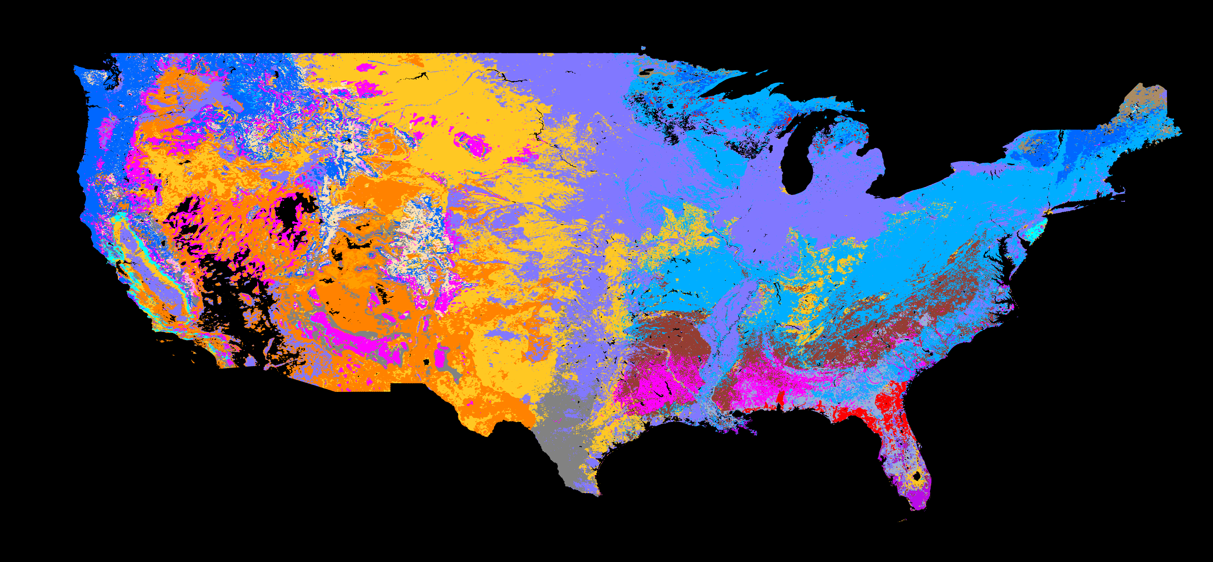

<https://github.com/subond/kbdi-ffdi/blob/master/README.md>

Here's a step-by-step guide:

Step 1: Installation

Install the NFDRS4 library using pip:

Code

pip install nfdrs4

Step 2: Import Necessary Libraries

Python

import nfdrs4  
import pandas as pd

Step 2: Prepare Weather Data

You'll need weather data in the FW21 format, which includes:

Temperature (°F), Relative Humidity (%), Wind Speed (mph), and Precipitation (inches).

You can either load this data from a file or create a pandas DataFrame. Here's an example DataFrame:

Python

weather_data = pd.DataFrame({  
 'temperature': [70, 75, 80],  
 'relative_humidity': [40, 35, 30],  
 'wind_speed': [10, 12, 15],  
 'precipitation': [0.0, 0.1, 0.0]  
})

Step 3: Calculate NFDRS Indexes

Python

# Create an NFDRS object  
nfdrs = nfdrs4.NFDRS()  
  
# Calculate indexes  
results = nfdrs.calculate(weather_data)  
  
# Print results  
print(results)

Step 4: Access Specific Indexes

Python

# Access the Burning Index (BI)  
bi = results['bi']  
  
# Access the Energy Release Component (ERC)  
erc = results['erc']  
  
# Access other indexes as needed

Important Considerations

* **Fuel Models:** NFDRS calculations require specifying a fuel model, which represents the type of vegetation in the area.
* **Data Format:** Ensure your weather data is in the correct format (FW21) and units.
* **Time Lag:** Some NFDRS components, like the 10-hour fuel moisture, require previous weather data.
* **More Complex Calculations:** For more advanced calculations, refer to the NFDRS4 documentation.
* **Keetch-Byram Drought Index (KBDI) – U.S. Forest Service:** <https://www.drought.gov/data-maps-tools/keetch-byram-drought-index>

<https://www.wfas.net/index.php?option=com_content&view=article&id=86&Itemid=487>

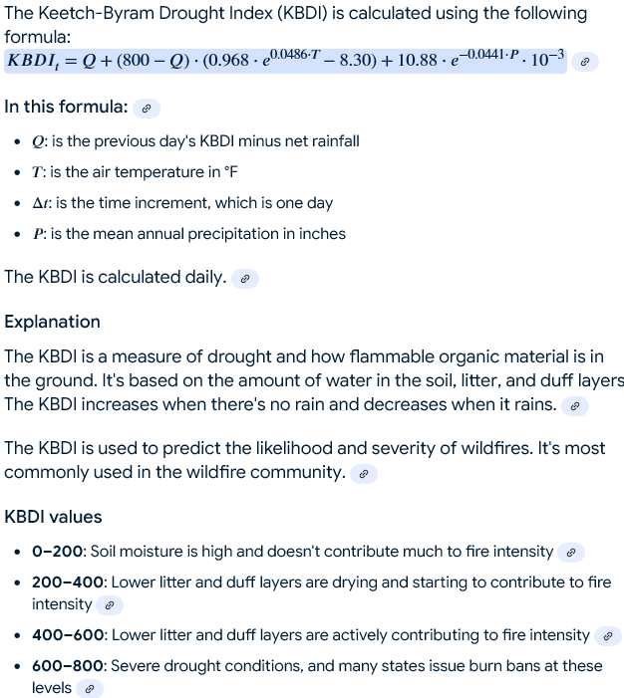

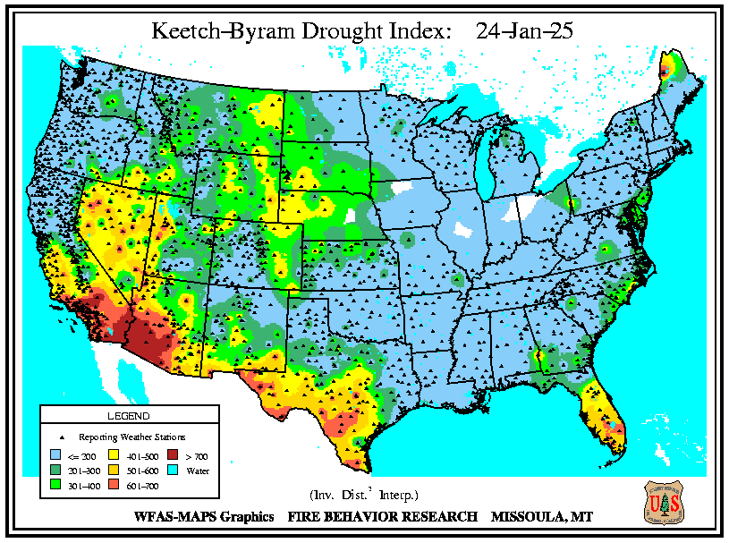

* **Alternative Libraries:** You can also explore the FireDanger Python library for calculating fire danger indexes.

Actual Python code:

import math

def calculate_fdi_us(ffmc, dmc, dc, bi, ws, build_up_effect=None):

"""

Calculates the Fire Danger Index (FDI) using the US National Fire Danger Rating System (NFDRS).

Args:

ffmc (float): Fine Fuel Moisture Code.

dmc (float): Duff Moisture Code.

dc (float): Drought Code.

bi (float): Buildup Index.

ws (float): Wind speed in miles per hour.

build_up_effect (float, optional): Build-up effect from the spread component. If not provided, it is calculated.

Returns:

float: Fire Danger Index (FDI). Returns -1 if inputs are invalid.

"""

# Input Validation

if any(x < 0 for x in [ffmc, dmc, dc, bi, ws]): # Check for negative inputs

return -1

# Calculate Spread Component

if ffmc <= 85:

sf = 147.2 * (101.0 - ffmc) / (59.5 + ffmc)

else:

sf = 6.2 * math.exp(0.133 * (ffmc - 84.0))

isi = sf * (1.0 + 0.536 * ws)

if build_up_effect is None:

build_up_effect = 1.0 + (bi * bi) / (4500.0) # Calculate build-up effect if not provided

ros = isi * build_up_effect # Rate of Spread

# Calculate Burning Index (BI - note: different from Buildup Index)

if dmc <= 0.4 * dc:

bi_burning_index = 0.00825 * dc * (1.0 - math.exp(-0.0667 * dmc))

elif dmc <= 1.4 * dc:

bi_burning_index = 0.00825 * dc * (1 - math.exp(-0.0667 * dmc)) + 1000.0 * (math.exp(-400.0 / (dc * dc))) * (1.0 - math.exp(-6.93 / dmc))

else:

bi_burning_index = 0.00825 * dc * (1 - math.exp(-0.0667 * 0.4 * dc)) + 1000.0 * (math.exp(-400.0 / (dc * dc))) * (1.0 - math.exp(-6.93 / (1.4 * dc))) + 0.0594 * (dmc - 1.4 * dc)

# Calculate Fire Danger Index (FDI)

fdi = 0.208 * ros * bi_burning_index

return fdi

# Example usage:

ffmc = 85.0

dmc = 15.0

dc = 100.0

bi = 50.0 # Buildup Index

ws = 10.0 # Wind speed in mph

fdi = calculate_fdi_us(ffmc, dmc, dc, bi, ws)

if fdi != -1:

print(f"Fire Danger Index (FDI): {fdi:.2f}")

else:

print("Error: Invalid input values (negative values not allowed).")

The default initial values (85 for FFMC, 6 for DMC, and 15 for DC) are chosen to represent relatively average or moderate fuel moisture conditions. They are not arbitrarily selected but are based on general observations and considerations

(<https://search.r-project.org/CRAN/refmans/cffdrs/html/fwi.html>):

* **FFMC (85):** An FFMC of 85 indicates moderately dry fine fuels. Values significantly lower would suggest very moist conditions, while higher values represent increasingly dry and flammable fuels. 85 is a reasonable starting point if no prior information is available, as it avoids extreme initial conditions that might skew subsequent calculations.
* **DMC (6):** A DMC of 6 indicates relatively moist duff (decomposed organic matter). Duff moisture content changes more slowly than fine fuel moisture. A value of 6 suggests that the deeper fuel layers are not exceptionally dry or wet, which is a common scenario.
* **DC (15):** A DC of 15 suggests moderate drought conditions in the deeper organic layers. Similar to DMC, the DC changes more slowly. A value of 15 represents a balanced starting point, avoiding extreme drought or excessively wet conditions.

**Why not 0 or 100?**

Using extreme initial values like 0 or 100 is generally avoided because they can lead to unrealistic results in the subsequent calculations, especially in the absence of historical data. The FWI system is designed to track changes in fuel moisture over time. Starting with an extreme value can artificially bias the calculations for the following days, especially since these indices are interconnected.

**When to Adjust Initial Values:**

While these defaults are suitable for many situations, you might consider adjusting them if you have specific knowledge about the fuel and weather conditions in your area. For example:

* **Very Wet Conditions:** If you know the area has experienced significant recent rainfall, you might lower the initial values (e.g., FFMC closer to 80, DMC and DC lower).
* **Very Dry Conditions:** If the area has experienced a prolonged drought, you might increase the initial values, but with caution, as overestimating initial dryness can lead to inflated FWI values.
* **Specific Knowledge/Historical Data:** If limited historical data is available, even just for a few days prior, averaging those values and using them as a starting point would be more appropriate than relying on generalized defaults.

**In summary**, the default values are reasonable approximations for average conditions, but adjusting them based on specific knowledge or available data can improve the accuracy of the FWI estimations, especially during extreme wet or dry periods. Using these defaults minimizes the risk of introducing significant bias due to unrealistic initial conditions when historical data is unavailable.

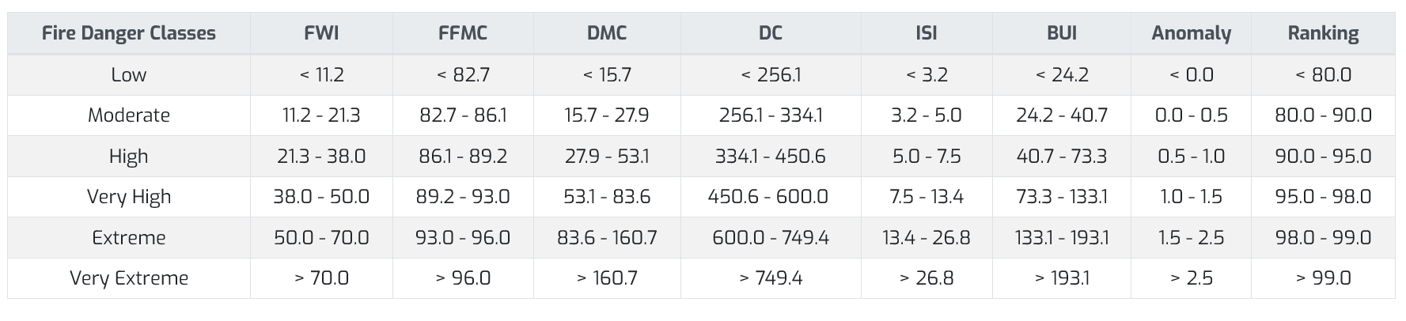

<https://gwis.jrc.ec.europa.eu/about-gwis/technical-background/fire-danger-forecast>

**Note:**

1. **Different Inputs:** The US NFDRS uses FFMC, DMC, DC, wind speed (miles per hour), and the Buildup Index (BI) directly as inputs. There's no "Adjusted ERB" or pre-calculated "Wind Effect" as in the Canadian system.
2. **Spread Component (ROS Calculation):** The spread component calculation is significantly different and involves a piecewise function based on FFMC. It also directly incorporates wind speed.
3. **Burning Index (BI - different from Buildup Index):** The US system calculates a "Burning Index" (which is *not* the same as the Buildup Index) based on DMC and DC. This Burning Index is a key factor in the FDI calculation. This code carefully differentiates between the "Buildup Index" (BI) and the calculated "Burning Index" for clarity.
4. **Build-up Effect:** The build-up effect is calculated based on the Buildup Index (BI), unless provided as an optional argument (sometimes, this is calculated as part of the spread component and provided separately).
5. **FDI Calculation:** The final FDI calculation uses the calculated rate of spread (ROS) and the Burning Index.
6. **Input Validation:** Checks for negative inputs and returns -1 if any are found, improving robustness.
7. **Clearer Variable Names:** Variable names (e.g., bi_burning_index to distinguish from the input bi) have been made more explicit to avoid confusion.

**When to Adjust Initial Values:**

While these defaults are suitable for many situations, you might consider adjusting them if you have specific knowledge about the fuel and weather conditions in your area. For example:

* **Very Wet Conditions:** If you know the area has experienced significant recent rainfall, you might lower the initial values (e.g., FFMC closer to 80, DMC and DC lower).
* **Very Dry Conditions:** If the area has experienced a prolonged drought, you might increase the initial values, but with caution, as overestimating initial dryness can lead to inflated FWI values.
* **Specific Knowledge/Historical Data:** If limited historical data is available, even just for a few days prior, averaging those values and using them as a starting point would be more appropriate than relying on generalized defaults.

**In summary**, the default values are reasonable approximations for average conditions, but adjusting them based on specific knowledge or available data can improve the accuracy of the FWI estimations, especially during extreme wet or dry periods. Using these defaults minimizes the risk of introducing significant bias due to unrealistic initial conditions when historical data is unavailable.

**Real-Time Forest Fire Localization Data:**

A good source for near real-time information on the geographic extent and details of California wildfires is the **Cal Fire website**:

**[https://www.fire.ca.gov/incidents/](https://www.google.com/url?sa=E&q=https%3A%2F%2Fwww.fire.ca.gov%2Fincidents%2F) **

This website provides an interactive map showing the location, size, and containment status of active fires. You can click on individual fires for more detailed information, including:

* **Acreage burned**
* **Containment percentage**
* **Personnel and equipment assigned**
* **Cause (if known)**
* **Evacuation information**
* **Road closures**

**Other useful resources:**

* **Mapping Support and Geospatial Information:** [https://egis.fire.ca.gov/](https://www.google.com/url?sa=E&q=https%3A%2F%2Fegis.fire.ca.gov%2F) This site from Cal Fire provides GIS data related to fire perimeters and other relevant information.

While a direct Cal Fire API isn't readily available, there are other potential avenues for accessing wildfire data programmatically:

1. **National Interagency Fire Center (NIFC) API:** NIFC provides an API with national fire data, including some information on California fires. You can find documentation here: [https://data-nifc.opendata.arcgis.com/](https://www.google.com/url?sa=E&q=https%3A%2F%2Fdata-nifc.opendata.arcgis.com%2F)
2. **GeoMAC Wildland Fire Support:** GeoMAC provides a variety of data, including perimeters in various formats (shapefiles, KML). They do not have a documented REST API, but their data is often used by developers who parse the available files. [https://www.geomac.gov/](https://www.google.com/url?sa=E&q=https%3A%2F%2Fwww.geomac.gov%2F) You might need to check their data download section and their "About Us" or "Contact" for details on data usage.